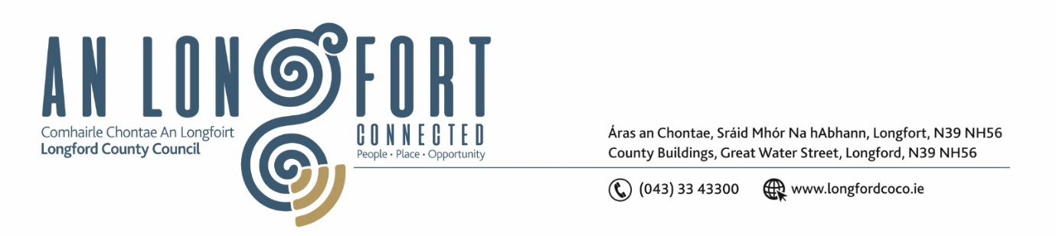

**LONGFORD MUNICIPAL DISTRICT**

**Minutes of Meeting of Longford Municipal District held in the Council Chamber Aras an Chontae and via MS Teams on Tuesday, 22 October 2024 at 11am.**

**CATHAOIRLEACH**: Councillor Seamus Butler

**MEMBERS PRESENT**: Councillors Martin Monaghan, Uruemu Adejinmi, Peggy Nolan, Kevin Hussey, Niall Gannon

**IN ATTENDANCE**: Mr. John Brannigan, Director of Services

Mr. John McKeon, Director of Services

Mr. Gerard Dennigan, Executive Secretary

Mr. David McNiff, Senior Executive Engineer

**MEETINGS**

**ADMINISTRATOR:**  Ms. Claire McNabola

**APOLOGIES:** Ms Lorraine McKee A/Senior Executive Officer

1. **CONSIDERATION OF GENERAL MUNICIPAL ALLOCATION 2025**

John McKeon, Head of Finance gave a comprehensive presentation regarding the General Municipal Allocation 2025 under the following headings and replied to queries raised –

* Budgetary Process – under Local Government Reform Act 2014
* Local Property Tax Variation – Retain LPT Rate at 2024 levels from 2025-2029
* Source of Funding for Municipal District
* Acute Financial Challenges for 2025
* No scope to increase local income
* Lowest valued LPT base in Country, maxed at 15%
* Funding new LCC Strategic Business Plan
* Commercial Rates Increase needed
* Rolling Rent Review needed
* Largest % population increase in the state
* Downward revaluations for Utility Providers
* New service initiatives only part funded
* Inflationary Pressures
* Ever increasing demands for match funding for Capital Projects
* Uisce Éireann Standard Costs
* Fire Service Costs
* Coats for providing services for Multiple Departments
* Rent Review
* Potential Deficit for 2024
* Recruitment Costs
* General Municipal Allocation 2025 Recommendation - €110,000 to be distributed as follows – Town Twinning – Voluntary Bodies – Tidy Towns/Development Committees – Art Activities – Other
* Governance

John McKeon provided detailed responses to all the questions raised.

On the proposal of Councillor Peggy Nolan, seconded by Councillor Martin Monaghan and the members agrees to adopt the suggested allocation as presented. To note that allocations can be amended within the budget throughout the year.

The Members thanked John McKeon and his Team for all their work.

1. **MULTI-ANNUAL (3-YEAR) RESTORATION IMPROVEMENT PROGRAMME**

David McNiff outlined the 3 Year Restoration Improvement Programme. David advised The Department guidance requires that a multi-year programme for 2025, 2026 and 2027 be prepared, assuming an annual budget estimate of 100% of your Council’s initial 2024 RI Grant allocation.

David thanked the Members for the collaboration and engagement in the preparation of the Restoration Improvement

The Members collectively thanked David and the entire Roads Team for all their great work, engagement and support

On the proposal of Councillor Martin Monaghan, seconded by Councillor Uruemu Adejinmi the members adopted the Multi Annual Restoration Improvement Programme.

This concluded the business of the meeting.

**Signed: ____________________**

**Claire McNabola,**

**Meetings Administrator.**

**Confirmed and adopted at Longford Municipal District Meeting held on the 26 November 2024.**

**Signed: _______________**

**Cathaoirleach**